**Hello Team!** **Consider the below two tables**:

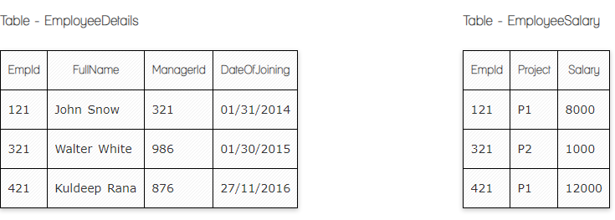

**Ques.1. Write a SQL query to fetch the count of employees working in project 'P1'.**

**Your Answer:**

**SELECT Project, count(EmpId)**

**FROM EmployeeSalary**

**GROUP BY Project**

**HAVING Project = ‘P1’**

**Ques.2. Write a SQL query to fetch employee names having salary greater than or equal to 5000 and less than or equal 10000.**

**Your Answer:**

**SELECT EmployeeDetails.FullName, EmployeeSalary.Salary**

**FROM EmployeeDetails**

**INNER JOIN EmployeeSalary**

**ON EmployeeDetails.EmplID= EmployeeSalary.EmplID**

**WHERE Salary between 5000 and 10000**

**Ques.3. Write a SQL query to fetch count of employees sorted by project's count in descending order.**

**Your Answer:**

**SELECT Project, Count(EmplID)**

**FROM EmployeeSalary**

**GROUP BY Project**

**ORDER BY Count(EmplID) desc**

**Ques.4. Write a query to fetch employee names and salary records. Return employee details even if the salary record is not present for the employee.**

**Your Answer:**

**SELECT EmployeeDetails.FullName, EmployeeSalary.Salary**

**FROM EmployeeDetails**

**LEFT JOIN EmployeeSalary**

**ON EmployeeDetails.EmplID= EmployeeSalary.EmplID**

**Ques.5. Write a SQL query to create an empty table with ‘Test’ name.**

**Your Answer:**

**CREATE TABLE Test (  
    ID int NOT NULL UNIQUE,  
    Name varchar(255) NOT NULL,  
    Age int,**

**PRIMARY KEY (ID)**

**);**

**Ques.6. Write a SQL query to delete an empty table with ‘Test’ name.**

**Your Answer:**

**DROP TABLE Test**

**Ques.7. Write a SQL query to fetch all the Employees details from EmployeeDetails table who joined in Year 2016.**

**Your Answer:**

**SELECT * FROM EmployeeDetails**

**WHERE DateOfJoining like ‘%2016’**

**--or**

**SELECT * FROM EmployeeDetails**

**WHERE DateOfJoining between ‘01/01/2016’ and ‘12/31/2016’**

**Ques.8. Write a SQL query to insert new record to the EmployeeDetails table with any data.**

**Your Answer:**

**INSERT INTO EmployeeDetails (FullName, DateOfJoining)**

**VALUES (’Anush Kh’, ‘02/17/2024’)**

**Ques.9. Write a SQL query to update EmployeeSalery table with setting Salary to 2000 for Project P2.**

**Your Answer:**

**UPDATE EmployeeSalery**

**SET Salary=2000**

**WHERE Project = P2**

**Ques.10. Write a SQL query to right join both tables and draw the results.**

**Your Answer:**

**Select * From EmployeeDetails right join EmployeeSalary ON EmployeeDetails.EmplID= EmployeeSalary.EmplID**

|  |  |  |  |  |  |  |
| --- | --- | --- | --- | --- | --- | --- |
| **EmplID** | **FullName** | **ManagerID** | **DateOfJoining** | **EmplID** | **Project** | **Salary** |
| **121** | **John Snow** | **321** | **01/31/2014** | **121** | **P1** | **8000** |
| **321** | **Walter White** | **986** | **01/30/2015** | **321** | **P2** | **1000** |
| **421** | **Kuldeep Rana** | **876** | **27/11/2016** | **421** | **P1** | **12000** |

**Select * From EmployeeSalary right join EmployeeDetails ON EmployeeSalary.EmplID= EmployeeDetails.EmplID**

|  |  |  |  |  |  |  |
| --- | --- | --- | --- | --- | --- | --- |
| **EmplID** | **Project** | **Salary** | **EmplID** | **FullName** | **ManagerID** | **DateOfJoining** |
| **121** | **P1** | **8000** | **121** | **John Snow** | **321** | **01/31/2014** |
| **321** | **P2** | **1000** | **321** | **Walter White** | **986** | **01/30/2015** |
| **421** | **P1** | **12000** | **421** | **Kuldeep Rana** | **876** | **27/11/2016** |

**Ques.10. Write a SQL query to right join both tables and draw the results.**

**Your Answer**

**Select addresses.city, users.id, users.full_name from addresses right join users ON addresses.user_id=users.id**

|  |  |  |
| --- | --- | --- |
| **city** | **id** | **full_name** |
| **San Francisco** | **1** | **John Smith** |
| **San Francisco** | **2** | **Alice Walker** |
| **Boston** | **3** | **Harry Potter** |
| **null** | **5** | **Jane Smith** |

**Select users.id, users.full_name, addresses.city from users right join addresses ON users.id= addresses.user_id**

|  |  |  |
| --- | --- | --- |
| **id** | **full_name** | **city** |
| **1** | **John Smith** | **San Francisco** |
| **2** | **Alice Walker** | **San Francisco** |
| **3** | **Harry Potter** | **Boston** |

**Now take these two tables:**

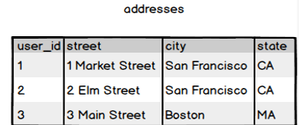

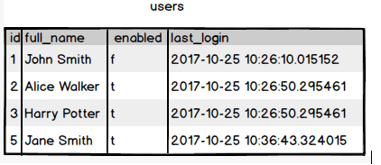

**Ques.11. Write a SQL query to fetch all users full_name from San Francisco.**

**Your Answer:**

**SELECT users.full_name**

**FROM users**

**INNER JOIN addresses**

**ON users.id=addresses.user_id**

**WHERE addresses.city = ‘San Francisco’**

**Ques.12. Write a SQL query to fetch all users full_name, last_login who are enabled**

**Your Answer:**

**SELECT full_name, last_login**

**FROM users**

**WHERE enabled= ‘t’**

**Ques.13. Write a SQL query to fetch all users full_name who are not from Main street**

**Your Answer:**

**SELECT users.full_name**

**FROM users**

**LEFT JOIN addresses**

**ON users.id=addresses.user_id**

**WHERE NOT addresses.street =’Main Street’**

**Ques.14. Write a SQL query to fetch all users full_name who are from Main street or San Francisco**

**Your Answer:**

**SELECT users.full_name**

**FROM users**

**INNER JOIN addresses on users.id=addresses.user_id**

**WHERE addresses.street =’Main Street’ or addresses.city=‘San Francisco’**

**Ques.15. Write a SQL query to fetch user full_name who is equal to user_id from Boston (find user_id value in sub_query)**

**Your Answer:**

**SELECT full_name from users**

**WHERE id=**

**(SELECT user_id from addresses WHERE city=’Boston’)**